Senario: If addon is not visible before review order page.

Addons are not visible to the given user because the default CPP (Catalog Personalization Policy ) is set to False.

So, there are two things to enable viewing the addons -
1 - If you are using the CPP feature, have a CPP that would allow the user to view the addon service based on the contexts passed on in the /catalog/v3/providers/aws/services/CB_AWS_CF_SQS_S00/addons API call that is made.
2 - Disable the CPP feature - this way addons will always be retrieved.

2 - Disable the CPP feature :

I. First GET the cpp's and check ID of Default cpp and Active field value

GET {{url}}/catalog/v3/policies/personalizations

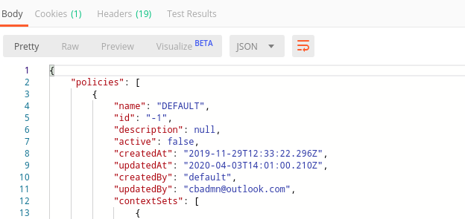

Here “ id ” : “ -1 ” and
“ active” : false

II. Pass id to PATCH API and use the payload for PATCH

PATCH {{url}}/catalog/v3/admin/policies/personalizations/{cpp_id}

Payload :

{
"active" : true
}
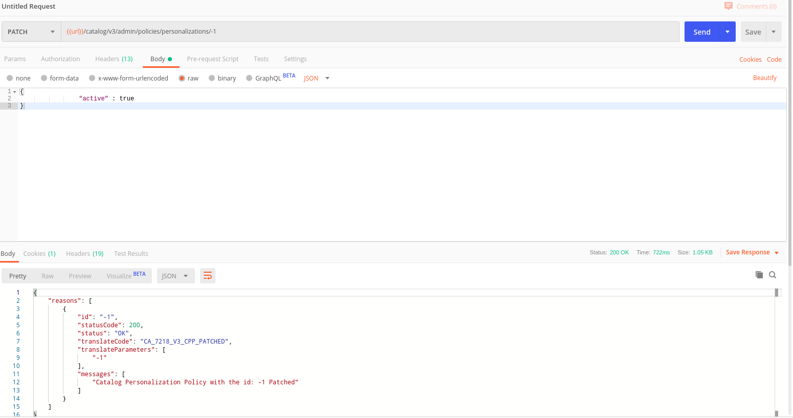

In this way we will be able to see the IMI Addon before review order page

